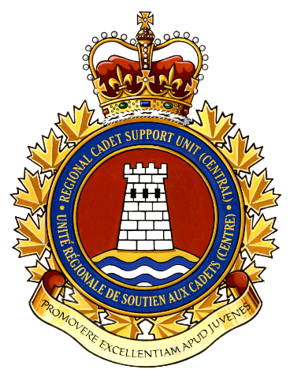
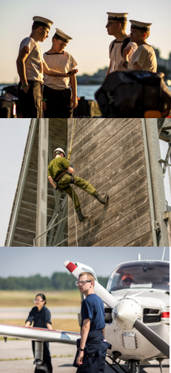
2021
Joining Instructions for all cadets attending the Cadet Activity Program in Central Region
for CADETS
COMMON JOINING INSTRUCTIONS
CADET ACTIVITY PROGRAM
Contents
Introduction
1. Purpose 3
2. Reading the Joining Instructions 3
Preparing for CAP 4
3. CAP Training Briefing 4
4. Packing for the CAP 4
5. Medication 5
6. Anaphylaxis Protocol 5
7. Medic-Alert Bracelets / Devices 5
Attending CAP
8. COVID-19 Protocol 5
9. Screening 5
10. Cohorting 6
11. Transportation 6
12. Food and Accommodations 6
13. Code of Conduct 7
14. Cease Training 7
15. Emergency Services 7
16. COA CAP Locations 8
17. NGTA CAP Locations 8
18. OSLA CAP Locations 9
19. NOA CAP Locations 9
20. SEOA CAP Location 10
21. SWOA CAP Locations 10
Common Forms 11
Common CAP JI Form – Authorization and Consent to Pick Up Cadet Form 12
Common CAP JI Form – Code of Conduct 13
Annex 16

Introduction

1. Purpose

The purpose of these Common Joining Instructions is to provide you with the foundation needed to prepare you for the Cadet Activity Program (CAP). Together, with the accompanying Annex, you must read each part in detail with your parents or guardians to ensure that you understand what is expected during your time at CAP.

2. Reading the Joining Instructions

These Joining Instructions have been written in a way that should be easy to navigate by bringing the most important information to you first. For example, what you should bring, what you should expect, etc. This information is common amongst all CAP locations in Central Region, so there should be no surprises when you arrive at your location.
Each CAP location has a specific document attached, called an Annex. If you’re not sure which CAP location you’re headed to, we’ve provided a list of locations on pages 10-12. Simply find your location, and its associated annex. If you’re still unsure, contact your Corps/Squadron Staff.

What You Should Have
Here’s what you should have:
- Common CAP Joining Instructions (this is the document you’re reading)
- Common CAP Joining Instructions Forms (found at the back of this document)
- CAP Instructions Annex Document (this is the document that tells you about your location)

Preparing for CAP

3. CAP Training Briefing

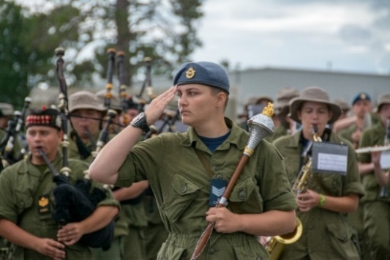
The CAP is a program of locally delivered day activities which will provide a fun, challenging, and meaningful experience for cadets above and beyond what they would receive at the corps/sqn level. This program will be conducted in-person over 5 days during the summer with no overnight requirements.

4. Packing for the CAP

As cadets may not have attended their corps/sqn in some time, all participants attending the CAP will wear appropriate civilian attire. You will need to ensure that proper footwear is worn, i.e. running shoes, as the activities will be interactive in nature.
The CAP will be conducted daily from 0800-1600hrs. As such, there is not a lot that would be required to pack for the day. We have provided a suggested kit list to bring each day. CAP staff may suggest additional items to bring on a particular day, which will be identified at the end of each day.
MANDATORY ITEMS (pack these things first!)
 | Provincial Health Card |  | Prescription Medication
 | Non-Medical Mask (NMM) |  | Over-the-Counter Medication (if needed)
 | Refillable Water Bottle |  | MedicAlert Identification (if needed)
 | Prescription Eyewear with protective strap
Additional Items
 | Backpack |  | Debit Card (preferred) or Cash (approx. $20)
 | Lip balm, SPF 15+ |  | Cell phone/Smartphone
 | Sunblock, SPF 50+

If you’re bringing personal electronic devices, or other valuables, you are responsible for these items – RCSU Central will not replace personal items which are lost or damaged during your time at CAP.

5. Medication

Medication will be your responsibility while attending CAP. You should bring what you would require during the day. Please make sure you bring them in their original packaging with name and dosage information clearly labeled. It is your responsibility to ensure that you are taking medication as prescribed.
Any over-the-counter medication, such as allergy medication or pain relief, must also remain in its original packaging.

6. Anaphylaxis Protocol

Anaphylaxis is defined as a serious allergic reaction that can be rapid in onset and may cause death. It affects about 2% of the Canadian population, with the most common allergens being food and insect stings. Medical attention is needed right away, as this type of reaction can be life-threatening.
Cadets with serious allergies to insect stings or food must bring prescribed Anakit/Epi-pen/Allerject with them to their location.
Cadets must carry a copy of their Anaphylaxis Emergency Plan completed during their annual medical validation to the CAP, and keep a copy on their person (with their emergency medication) at all times.

7. Medic-Alert Bracelets / Devices

It is highly recommended that all cadets with known medical conditions requiring immediate identification, wear their Medic-Alert devices (bracelets, necklaces, etc.) at all times.

Attending CAP

8. COVID-19 Protocol

All CAP activities have been prepared and will be conducted adhering to the most restrictive guidelines by all levels of government and public health directives of the specific province, region, city, or municipality.

Notwithstanding cadets that are attending CAP may have received individual vaccinations prior to attending, we are conducting CAP in accordance with direction from the Commander, Cadets and Junior Canadian Rangers (CJCR) and provincial guidelines for day camps.

Upon arrival to the training facility, all cadets and staff must:

a. ensure to wear NMM before entering any training site/facility;
b. sanitize their hands, prior to entering the training site/facility;
c. sign in with the staff, providing name, contact phone number and email for contact tracing;
d. provide COVID-19 screening questionnaire; and
e. ensure to maintain social distancing at all times, 2 metres (6 feet).

All cadets and staff will participate in a COVID-19 Safety Briefing to be held at the beginning of each day.

9. Screening

Cadets will be subject to medical screening by CAP staff. This is to prevent the spread of communicable diseases, contagious conditions, and to assess that you’re medically fit for training.
COVID-19 screening will be conducted for all cadets and staff upon arrival each day of the CAP. Cadets that display symptoms of COVID-19 may be asked to not participate in the CAP.

Cadets can use the Ontario COVID-19 screening tools found at https://covid-19.ontario.ca/screen-covid-19-going-any-public-place. Cadets participating should use the School and Child Care screening tool and provide the results either on their smartphone (Screen Shot) or a paper copy upon check-in.

For those cadets that may not be able to use the Ontario COVID-19 screening tool, an in-person screening questionnaire will be provided upon arrival at the CAP location.

10. Cohorting

In order to minimize the chances for COVID-19 transmission, the practice of cohorting will be used during CAP. Interactions between cadets and staff shall remain limited to individual training groups, (i.e. divisions / platoon / flights, groups, etc.).

11. Transportation

For most cases, you will be required to provide your own transportation to the training site. The training site will be located no more than 50 KM from your residence. Your parent or guardian will be required to drop you off at the training location and pick you up at days end.
Closer to the CAP start date, you will be provided with a travel information from your corps/sqn. This information will include a date, time and location for your CAP.
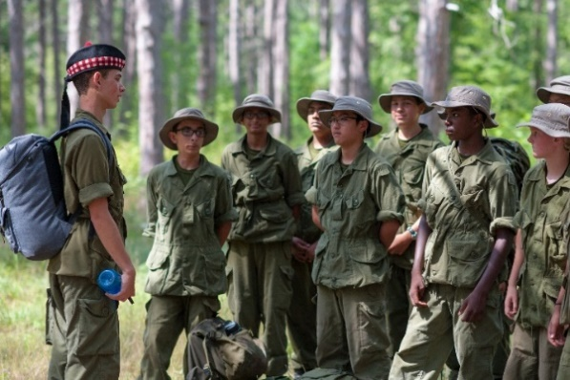
At the end of each day, you’ll be required to stick around for a little while to finish up last minute end-of-CAP information. We will not release a cadet to someone who is not authorized (by a parent or legal guardian) to take them. Any parent that wishes to have someone else not on the authorized list pick up their cadet requires to fill out the Authorization and Consent to Pick up Cadet form.

12. Food and Accommodations

Lunch will be provided for the duration of your CAP. While food options are available, it is the individual’s responsibility to comply with any dietary restrictions they may have. Not all food allergies can be accommodated by the CAP staff
Meals will be either catered by a local supplier or military-style boil in the bag Meals Ready to Eat (MREs) will be given to cadets. This may change depending on your CAP location or building availability. Rest-assured though, you will be fed.
Cadets will be expected to travel to the training site daily and travel home at night, so there will be no need for accommodations.

13. Code of Conduct

As the CAP is meant to be a fun and exciting experience, there is still an expectation for cadets to carry themselves in an appropriate manner, as you would at any cadet activity. There will be some relaxing of standards regarding dress, as cadets will be in appropriate civilian attire. Hair, jewelry and make-up standards may be relaxed for the CAP.
Each CAP has an established expectation of behaviour. Every person attending these activities are to adhere to this behaviour without question. This is called a “Code of Conduct” and is similar to the one you signed when you joined the program. You are required to read and sign this Code of Conduct, attached, before you start your CAP.
Breaches of this Code of Conduct will result in disciplinary action up to and including removal from the CAP.
Orders, rules, and regulations exist to ensure the safety of all personnel attending or working on the CAP. They must be strictly followed to maintain order, discipline, and safety.

14. Cease Training

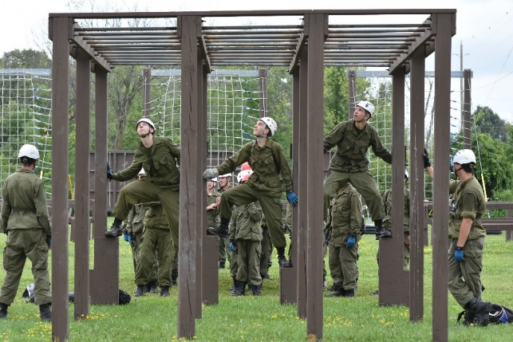
Circumstances may arise during CAP where you may be required to go home. This could be due, but not limited to,
- unable to adapt to the training;
- become a disciplinary or safety concern; or
- a medical concern that precludes them from participating.
In these cases, the CAP staff will contact your parent(s)/guardian(s) in order to pick you up from the CAP location.

15. Emergency Services

Cadets are covered through the Ontario Health Insurance Plan (OHIP), and the Department of National Defense for all health-related expenses while attending training.
Each CAP location will have a Hospital or Clinic in the nearby area, which will tend to emergency medical needs as they arise. Staff conducting the CAP will be qualified in basic first aid and CPR.
In case of an emergency, 911 will be contacted and an ambulance will transport the cadet to the nearest hospital. Parent(s)/Guardian will be contacted to meet the cadet at the hospital.
 |  | CAP Dates |  |  |  | Units
Site | Location(s) | Serial A | Serial B | Serial C | Serial D | Sea | Army | Air
Alliston | Alliston Legion, Earl Rowe Park, CFB Borden | 16-20 Aug |  |  |  |  | 329, 2408 | 164, 734
Bracebridge | TBC | 9-13 Aug |  |  |  |  | 2250
Brampton | Brampton Armoury | 2-6 Aug | 9-13 Aug | 16-20 Aug | 23-27 Aug | 139, 253 | 557 | 132, 283, 758
Coboconk | RCL Hall, Camp Endobanah | 2-6 Aug |  |  |  | 314
Erin | Erin Agricultural Centre | 9-13 Aug | 16-20 Aug | 23-27 Aug |  |  | 676, 1849 | 85, 197, 242, 756, 892
Hillsdale | Hillsdale Community Centre | 26-30 Jul | 2-6 Aug | 9-13 Aug | 16-20 Aug | 53, 286 | 2919 | 99, 102, 724
Listowel | RCL Hall | 23-27 Aug |  |  |  |  | 1943, 2967 | 769, 812, 895
Newmarket | Aurora Legion, Aurora Family Leisure Complex | 26-30 Jul | 2-6 Aug | 9-13 Aug |  | 221 | 32, 142, 2799 | 37, 94, 140
Owen Sound | Harrison Park, Meaford | 9-13 Aug |  |  |  |  | 42 | 167, 340
Richmond Hill | TBC | 2-6 Aug | 9-13 Aug | 16-20 Aug | 23-27 Aug |  |  | 8, 351, 707, 778
Wingham | Wingham Legion, North Huron Comm Centre | 26-30 Jul |  |  |  |  |  | 183, 532, 543

16. COA CAP Locations
 |  | CAP Dates |  |  |  | Units
Site | Location(s) | Serial A | Serial B | Serial C | Serial D | Sea | Army | Air
Denison | Denison Armoury | 9-13 Aug |  |  |  | 17 | 2402, 2754 | 166, 180, 188
Fort York | HMCS York | 9-13 Aug |  |  |  | 18, 272 | 48, 75, 337, 709, 2736 | 142, 246, 618, 818
Mississauga | Mississauga Cadet Centre | 9-13 Aug | 16-20 Aug |  |  | 186 | 105, 2824 | 700, 789, 800, 845
Oakville/Burlington | Haber Centre | 9-13 Aug | 16-20 Aug |  |  | 65, 178 | 1188, 2379 | 540, 715
Scarborough | Centennial College | 9-13 Aug |  |  |  | 176 | 748, 1888, 2881 | 110, 330, 631, 876, 883
St Catharines | Lake Street Armoury | 9-13 Aug | 16-20 Aug |  |  | 103, 358 | 68, 162, 2835 | 23, 62, 87, 126, 128, 809

17. NGTA CAP Locations

18. OSLA CAP Locations

19. NOA CAP Locations

 |  | CAP Dates |  |  |  | Units
Site | Location(s) | Serial 1 | Serial A | Serial B | Serial C | Sea | Army | Air
Arnprior | 77 James St |  | 9-13 Aug |  |  |  | 2360 | 653
Carleton Place | 137 John St |  | 9-13 Aug |  |  | 211, 338 |  | 585
Connaught (Ottawa) | Connaught CTC, 5 Brouillette |  | 9-13 Aug | 16-20 Aug | 23-27 Aug | 319 | 2784, 2870
Cornwall  Pringle Memorial Campground, | 16380 Fran Laflamme Drive, Long Sault |  |  | 16-20 Aug | 23-27 Aug | 110 | 57, 2403, 2804 | 253, 325
CFB Petawawa | O-9 21 Langemark Rd, |  |  | 16-20 Aug |  |  | 2642, 2677 | 638
Prescott | 850 Sophia St, |  |  |  | 23-27 Aug |  | 113 | 661, 870
Uplands (Ottawa) | 30th Fld, 307 De Niverville Pvt,  , | 2-6 Aug | 9-13 Aug | 16-20 Aug | 23-27 Aug | 40 | 137, 2317, 2332, 2951, 3018, 2958
 |  | CAP Dates |  |  |  | Units
Site | Location(s) | Serial A | Serial B | Serial C | Serial D | Sea | Army | Air
Englehart | TBC | 16-20 Aug |  |  |  |  | 2344 | 288, 355
North Bay | Fort Chipewa / CFB North Bay | 9-13 Aug |  |  |  | 104 | 204 | 547
Sault Ste. Marie | Algoma Rod & Gun Club | 16-20 Aug |  |  |  | 46 | 2310 | 155
Sudbury | Sudbury Armoury / other | 16-20 Aug |  |  |  | 134 | 2912, 2915, 2964 | 200
Thunder Bay | Armoury / other | 9-13 Aug |  |  |  | 42, 309 | 2294, 2511 | 70
Timmins | Cassidy Armoury | 9-13 Aug |  |  |  | 101 | 1884 | 10, 792

20. SEOA CAP Locations
 |  | CAP Dates |  |  |  | Units
Site | Location(s) | Serial A | Serial B | Serial C | Serial D | Sea | Army | Air
Bancroft | Bancroft Fish and Game Club | 2-6 Aug |  |  |  | 229
Madoc | Madoc Kiwanis Club | 9-13 Aug |  |  |  |  | 385
Oshawa | McClaughlin Armoury | 16-20 Aug | 23-27 Aug |  |  | 106, 226, 244, 279 | 1913, 2525 | 2, 151, 172, 856
Port Hope | Northumberland Navy League Building | 23-27 Aug |  |  |  | 116 | 88 | 598, 718
Trenton | RC Legion Branch 110 | 23-27 Aug |  |  |  | 58, 79 | 100, 2818 | 173, 608, 704
 |  | CAP Dates |  |  |  | Units
Site | Location(s) | Serial A | Serial B | Serial C | Serial D | Sea | Army | Air
Brantford | Navy League Bldg | 16-20 Aug |  |  |  | 135, 153 | 109, 2833, 2659 | 104, 153, 201
Hamilton | 779 RCACS Building | 23-27 Aug |  |  |  | 31, 96, 308 | 62, 2347, 2814, 2865 | 150, 713, 735, 779, 826
Kitchener | Cadet Youth Development Centre | 16-20 Aug |  |  |  | 89, 94 | 21, 1596, 1882 | 80, 121, 296, 530, 822
London | Salvation Army - London Village | 23-27 Aug |  |  |  | 37 | 7, 9, 223, 2923, 3144 | 19, 27, 614, 741, 862
Petrolia | 2653 RCACC Building | 16-20 Aug |  |  |  | 132 | 11, 59, 102, 2563, 2884, 2918 | 3, 44, 294
Windsor | 364 RCACS Building | 16-20 Aug |  |  |  | 48 | 202, 1086, 1112, 2715, 2828, 2861 | 364, 535

21. SWOA CAP Locations

NOTE: Locations/Serials are subject to change based upon registrations. Please check with your Corps/Sqn CO for updates to Locations/Serials.

Common Forms
The following forms must be completed in their entirety, and returned with you to the CAP Site Staff. Please note that these common forms may not be the only ones required for your CAP. Consult your CAP package for more information.
Common CAP JI Form – Authorization and Consent to Pick Up Cadet Form
- This form allows parents to authorize people not listed in FORTRESS identified on the form, to pick up cadets at the end of the training day. Photo identification is required at pick-up.

Common CAP JI Form – Code of Conduct
- This document is the Cadet Code of Conduct that must be signed and handed in to the CAP staff when you check-in.

Protected A (when completed)
Common CAP JI Form – Authorization and Consent to Pick up Cadet
Instructions:
Complete this form with as much detail as possible if someone other than an authorized person will pick up your cadet(s) . This form must be completed by a parent or guardian.
1. CADET IDENTIFICATION
Cadet Name: |  |  |  |  |  | CIN:
Corps/Sqn: |  |  |  |  |  | Location:
CAP Area: |  |  |  |  |  | Location:
Phone Number:
3. AUTHORIZED PERSONNEL IDENTIFICATION
Without prior arrangements, your cadet will not be released to anyone other than a parent, legal guardian, or people identified below. Government-issued Photo Identification is required when picking up a cadet. If you wish to authorize more people, please identify them on the reverse side of this page.
Name:
Phone Number: |  |  |  |  | Relationship to Cadet:
 |  |  |  |  | Driver’s License Number:
Name:
Phone Number: |  |  |  |  | Relationship to Cadet:
 |  |  |  |  | Driver’s License Number:
Name:
Phone Number: |  |  |  |  | Relationship to Cadet:
 |  |  |  |  | Driver’s License Number:
4. DECLARATION
Parent / Guardian (Signature)
 |  |  |  |  |  |  | Date
Parent / Guardian (Print Name)
Protected A (when completed)
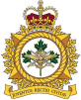
CADETS AND JUNIOR CANADIAN RANGERS
YOUTH CODE OF CONDUCT

Rank | Last Name | First Name | Home Corps / Squadron / Patrol

- Cadets and Junior Canadian Rangers (CJCR) is committed to providing a safe, welcoming, and supportive environment where adult staff, cadets and Junior Canadian Rangers (JCRs) feel valued and can develop to their maximum potential. Treating every person within our organization with respect and fairness, acting and making decisions in their best interest and working objectively within the parameters of CJCR orders, policies and directives are at the core of our daily operations. We foster supportive relationships with cadets/JCRs within appropriate boundaries in order to promote and maintain a culture free from all forms of discrimination, abuse, inappropriate conduct and damaging behaviour.

- Your behaviour, at all training activities whether in person or virtual, impacts this environment. CJCR orders, policies, and directives have been developed and provided to you through training programs to ensure you are successful in maintaining this positive environment. In addition, this Code of Conduct has been developed, for you as a cadet/JCR, in order to provide an opportunity for you to:

  - review, reflect on and discuss the key behaviours that are expected of you as a cadet/JCR;

  - acknowledge your commitment and responsibility to continuing to learn about and abide by all CJCR orders, policies, and directives; and

  - acknowledge that you will continue to align your behaviour with the values of the organization and respect the Laws of Canada, including the Canadian Human Rights Act and the Charter of Rights and Freedoms.

- Codes of conduct are read, discussed and signed at the start of summer training. Signing this code means you are committed to doing what is right and demonstrating courage to challenge inappropriate actions and behaviour. It also means you recognize the requirement to continue to behave in ways that align to CJCR policies, values, and direction. A summary of expected behaviours is provided below. Please note this list does not include all behaviours.

- As a cadet/JCR I understand I am responsible to:

  - set a positive example for conduct. My actions and behaviours will be kind;

  - be respectful of others, including their physical boundaries, personal property, and privacy;

  - be honest;

  - treat everyone fairly;

  - follow the decisions and direction of my leaders;

  - use a calm and reasonable tone of voice when interacting with others, particularly when giving instruction or addressing concerns;

  - ensure that I am always acting in a safe manner when participating in cadet/JCR activities; looking out for my own safety and the safety of others;
  - report any wrongdoing that I am aware of to an adult staff member as soon as possible;

  - think about how my actions will impact others and the environment before deciding how I will behave;

  - be respectful of the environment and my surroundings at all times;

  - behave in a way that is consistent with this code while on social media sites and any other electronic communications, such as CADET365, even on my personal time;

  - ensure my uniform is clean and in good repair and that I am wearing it as outlined in dress regulations;

  - request the assistance of a senior cadet/JCR or adult staff member when I need help;

  - take care of all clothing, materials and equipment that are loaned to me;

  - refrain from behaviours that are illegal and are forbidden by policy. I WILL NOT:

    - intentionally violate orders, policies and directives;

    - be offensive or make derogatory remarks towards any person’s race, national or ethnic origin, colour, religion, age, gender, sexual orientation, marital status, family status, disability, gender identity or expression, genetic characteristics, or physical characteristics (through comments made verbally or in writing, as well as by electronic communications and on social media);

    - behave in a way that is of a sexual nature or has sexual undertones (through verbal or written comments, electronic communications, gestures, displays or physical contact);

    - have pornographic materials in my possession;

    - access pornographic materials including through the use of computers or other electronic devices;

    - touch other cadets/JCRs and/or their belongings without their permission except when absolutely necessary in an emergency situation;

    - take pictures of other cadets/JCRs without their consent;

    - distribute or share pictures of others on social media without their consent (via email, text or other means);

    - use or possess tobacco, while participating in cadet/JCR activities, except for approved ceremonial purposes;

    - purchase or sell tobacco, e-cigarettes, or cannabis products while participating in cadet/JCR activities;

    - consume, purchase, possess or sell alcohol while participating in cadet/JCR activities;

    - use, purchase, possess or sell illegal or non-prescription drugs that would alter behaviour while participating in cadet/JCR activities;

    - share medication that is for my treatment with any other person; and

    - have knives, guns, weapons or ammunition in my possession other than those provided for participation in approved activities.

- I understand that my actions and behaviours have impacts. Any that negatively affect others or takes us away from our mission of creating an environment free from all forms of discrimination, abuse, inappropriate conduct and damaging behaviour, will not be tolerated.

- By signing this Code of Conduct, I acknowledge that I have read, discussed and understand the Code of Conduct. I understand that through my positive behaviour I will help make CJCR a safe place where all members feel welcomed, valued and included. I understand that failure to comply may result in corrective and/or disciplinary action as necessary and outlined in policy and law. This may include administrative action, or legal action, termination of membership and may include involvement of the military or civilian police.

Date Cadet / JCR Signature (Print Name and Sign)

I have reviewed the Code of Conduct with the above cadet/JCR and clarified their understanding of the content within.

Date Adult Leader (CAF member / CI Signature) (Print Name and Sign)

This includes communication by email, instant messaging, online chatting, and texting and via social media.
Term inclusive of Regular Force, Primary Reserve, COATS and Canadian Rangers.

