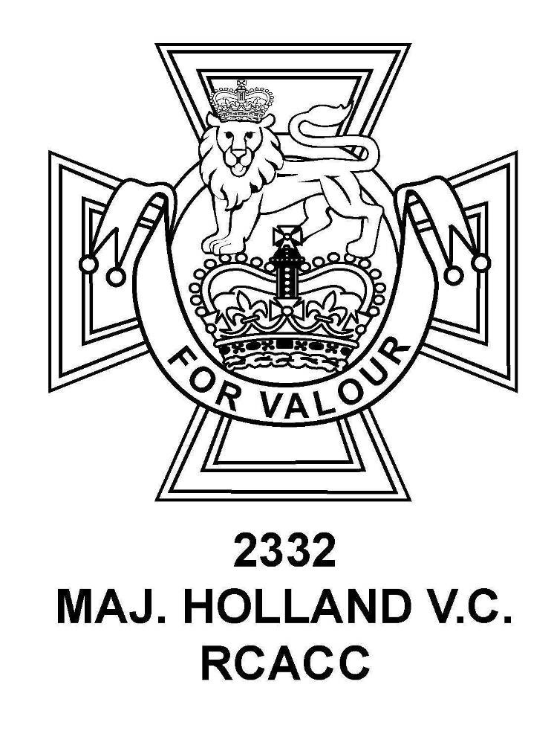

2332 Major Holland VC
Royal Canadian Army Cadet Corps

Support Committee

Captain John Butterworth Bursary

When Captain Butterworth passed away he bequeathed a sum of money to 2332 RCACC to be distributed to Cadets in a manner that would best exemplify his passion for the Cadet program. The Support Committee will provide the Captain John Butterworth Memorial Bursary annually, in the amount of $1000 each, to two deserving cadets (for as long as the fund can maintain its value).

The criteria for the bursary are as follows:

- The applicants must have successfully completed their OSSD (Ontario Secondary School Diploma) or CEGEP in Quebec
- The applicants must have been accepted to or are presently attending an accredited post-secondary institution (university, college or trade school), the RCAF or an apprenticeship program
- The applicants must have completed the Gold Star qualification and are presently working on the National Star of Excellence levels and subsequent master Cadet Qualification
- The applicants must exhibit a dedication to the Cadet Program and 2332 RCACC specifically, as demonstrated by their participation in optional training, exercises and Corps team participation
- The applicants must be an example for junior cadets as observed by the Officers and Support Committee members
- The applicants must demonstrate interests in other activities within their community and school

The application must be submitted to the Support Committee of 2332 RCACC on or before May 15th of each year. The decision will be made by the Support Committee and the Commanding Officer by June 1st and the recipients will be awarded the bursary at the Annual Cadet Review.

Captain John Butterworth Memorial Bursary Application

Date: ____________

Name of Applicant: _________________________________ Rank: _______________
Last, first

Star Level: _______ NSE Level: ______ No. of years with 2332 RCACC: _______

Secondary School at Graduation: _______________________________________________

Answers to the following questions should be typed, double spaced (if not possible, very neatly handwritten) and be approximately 20-25 lines for each answer.

1. Briefly express your understanding of the Army Cadet Organization as it pertains to the history of the program and the objectives.

2. Briefly express your understanding of the 2332 Maj. E.J.G. Holland VC RCACC as it pertains to the history of the corps and Maj. Holland VC for whom it was named as well as your understanding of the involvement and contributions of Capt. John Butterworth.

3. Outline your accomplishments and activities with 2332 RCACC.

4. Outline your activities toward achieving the Master Cadet Badge and the activities you have done towards achieving your NSE levels.

5. Outline your accomplishments and activities outside within your community / school / sports organizations.

6. Explain why you are the most deserving applicant and should be awarded the Captain John Butterworth Bursary.

